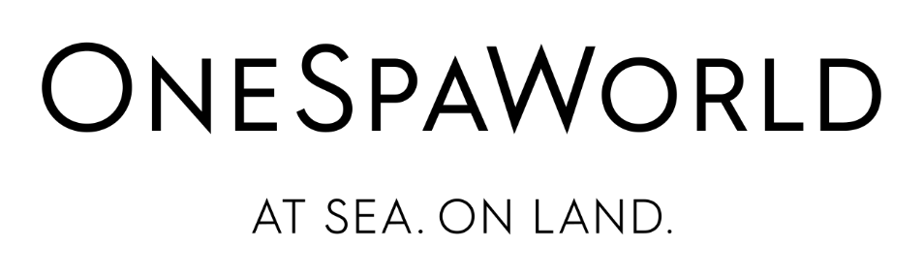

OneSpaWorld Announces Third Quarter 2021 Financial Results on November 3, 2021

(New York, NY) – October 27, 2021 - OneSpaWorld Holdings Limited, (NASDAQ: OSW), the pre-eminent global provider of health and wellness products and services on board cruise ships and in destination resorts around the world, announced today that it will release its Third Quarter 2021 earnings on Wednesday, November 3rd before market open. The Company will conduct a conference call the same day at 9:00 am ET to discuss its quarterly results.
What: OneSpaWorld Third quarter 2021 financial results conference call.
When: Wednesday, November 3rd at 9:00 am ET.
Webcast: A live webcast of the conference call can be accessed from the Investor Relations section of OneSpaWorld's website at www.onespaworld.com.
Dial-in: To access the live conference call, please dial (855) 327-6837 (international dialers please dial (631) 891-4304) and use the passcode 10016773.
Replay: An audio replay of the conference call can be accessed at (844) 512-2921 (international dialers (412) 317-6671), passcode 10016773. The conference call replay will be available approximately two hours after the call and remain in effect for one week. A replay of the webcast will be available for 90 days at www.onespaworld.com.

About OneSpaWorld:
Headquartered in Nassau, Bahamas, OneSpaWorld is one of the largest health and wellness services companies in the world. OneSpaWorld’s distinguished spas offer guests a comprehensive suite of premium health, wellness, fitness and beauty services, treatments, and products currently onboard 169 cruise ships and at 53 destination resorts around the world. OneSpaWorld holds the leading market position within the fast-growing international leisure market that has been built upon its exceptional service standards, expansive global recruitment, training and logistics platforms, and a history of service and product innovation that has enhanced its guests’ personal care experiences while vacationing for over 65 years.

Contact:
ICR:
Investors:
Allison Malkin, 203-682-8225
allison.malkin@icrinc.com

Follow OneSpaWorld:
Instagram: @onespaworld
Twitter: @onespaworld
LinkedIn: OneSpaWorld
www.onespaworld.com
https://www.facebook.com/onespaworld/

